TML project at Exeter’s Centre for Translating Cultures. An audio recording of this lecture is now available
30 Oct 2015, by cp14603 in News
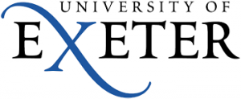Charles Burdett and Barbara Spadaro presents the TML project at Exeter’s Centre for Translating Cultures.
This talk will present the progress of the AHRC large grant Transnationalizing Modern Languages: Mobility, Identity and Translation in Modern Italian Cultures. The project aims to explore the ways in which Italian communities have formed across the world and it examines the wealth of publications and materials – journals, literature, life stories, photographs, collections of memorabilia – that have represented the transnational experience of these communities. The talk will discuss the range of research that is being conducted within the project: for example, the multiple ways in which ideas of Italian belonging are mobilized, re-actualized and kept alive through processes of ‘travelling memory’ (Erll) that shape individual and collective subjectivities. The panel will also address the wider question of the relation of Italian studies to Modern Languages. From the insights it develops into transnational Italian cultures, the project aims to present a new framework for Modern Languages as a whole, one which places the interaction of languages and cultures at its core. The panel will talk about the impact activities that are currently taking place, and it will focus on the range of publications that are being planned within the project, discussing how they are intended to contribute to the reframing of Modern Languages.
An audio recording of this lecture is now available.

