Writing Without Frontiers – Wednesday 23rd September 2015

Present:
Vicki Jarrett
Zoe Jonstone
Lindsay Martindale
Gail Mohamed
Juan Manuel Armasmartin
Carol Li

What’s in a name?
A lot as it turns out – mysterious white horses, jars of honey, the unpredictable choices of fathers, the shape of the sound of a name, ancestral metalworkers…and an awful lot more.
This exercise, apart from being an interesting way of introducing ourselves to each other is a neat illustration of an important point – stories are everywhere, lurking under the everyday and seemingly ordinary things, bits of our lives we take for granted and hardly notice – even five minutes of examination can turn up a wealth of multi-layered stories and personal resonances.
Note: This can be a useful technique when creating a fictional character –why do they have the name they have? (Pretend it’s not simply because that’s the name you gave them!) How do they feel about it? What do the answers to these questions reveal? We’ll explore character creation more fully at a later date.

Transnationalizing Modern Languages
We talked about the Transnationalizing project, how it got started, its general aims and how that relates to what we can do within our 2 hours on a Wednesday evening.
This resulted in a messy whiteboard:
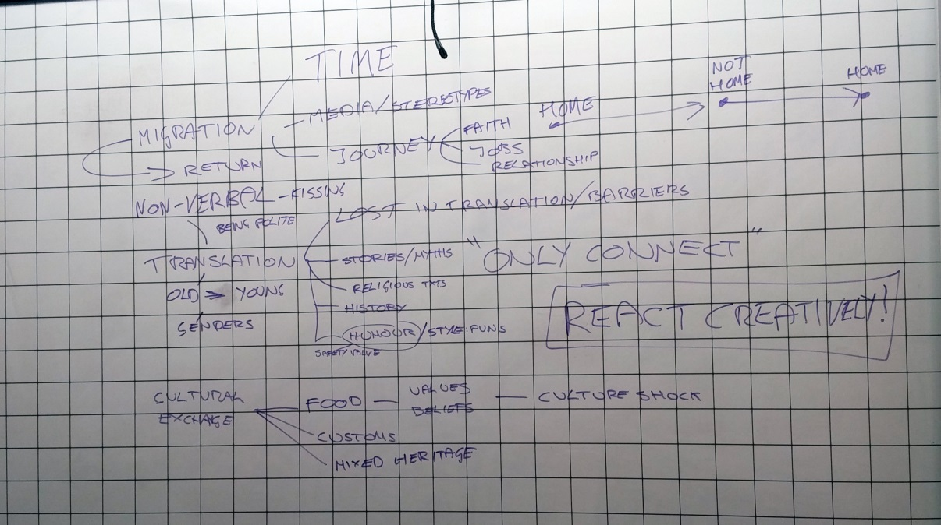
Not a great picture and don’t worry about getting all the terms we put up there – there were lots more we didn’t write down but are equally relevant. The main thing we discovered is that exploring our core themes of:
- Migration
- Translation
- Cultural exchange
…can take many different routes. Ideas of journeys and connections are both incredibly broad and nested within each other. There are big ideas, universal themes of human experience and subtleties and nuances within these themes. As we go through the next 10 weeks, I’d encourage you to pursue whatever route through these themes appeals to you most. In the exercises and topics we cover, we’ll be using the core themes as a framework.

Ideas
We touched briefly on the question most often asked of writers – where do you get your ideas from? The answer is – the same place as everyone else. They’re everywhere. Every human head is a constant stream of them. They are made of impressions (via the senses), memories, abstract feelings, news stories, overheard conversations, dreams etc. The only difference between writers and non-writers is that writers write them down. Which brings us to…

Notebooks
This basic piece of equipment is the writer’s constant companion. Use it freely to record the random thoughts and impressions, fragments that might seem irrelevant or small. The main thing is to get into the habit of recording them without worrying about whether or not they are significant. Nothing is altogether irrelevant.
There’s a Virginia Woolf quote that fits here, although she was talking primarily of keeping a diary:
“… if I stopped and took thought, it would never be written at all; and the advantage of the method is that it sweeps up accidentally several stray matters which I should exclude if I hesitated, but which are the diamonds of the dustheap.”
So, think of your notebooks as your dustheaps in the making.

Homework
Think about the discussion we had around our central themes – is there a particular aspect of what we talked about that particularly calls to you as something you’d like to explore in writing? You don’t need to focus too tightly at this stage, but just start feeling around the ideas, looking for that ‘glow’ of interest.
Get used to carrying your notebook around – try to use it daily, no matter if it’s only a couple of words, no matter if you think those two words are stupid, or pointless - the idea is to plant the small seeds of a writing habit.

